**Assam**

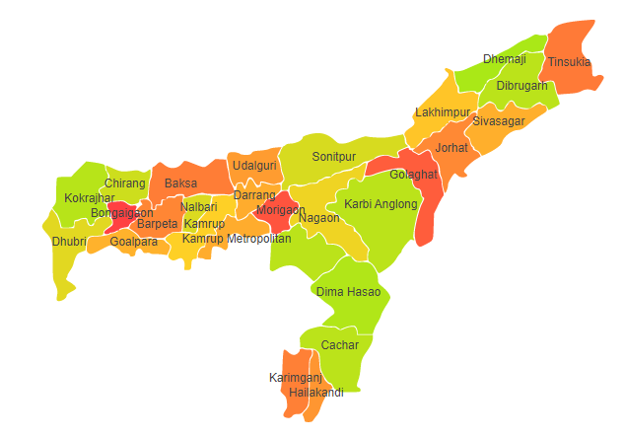

Assam comprises of two Agro Ecological Regions (AER) namely 15 and 17.

**Agro-Eco Region 15 :** AER 15 in Assam comprises of Baksa, Barpeta, Bongaigaon, Cachar, Chirang, Darrang, Dhubri, Dhemaji, Dibrugarh, Goalpara, Golaghat, Hailakandi, Jorhat, Kamrup Metro, Kamrup Rural, Karimganj, Kokrajhar, Karbi Analog, Lakhimpur, Morigaon, Nagaon, Nalbari, Sibsagar, Sonitpur, Tinsukia and Udalguri districts of Bengal and Assam Plain under Agro Ecological Sub Regions (AESR) 15.2, 15.3 and 15.4.

**Agro-Eco Region 17 :** AER 17 in Assam comprises of N.C Hills district of North-eastern Hills (Purvachal) basin under Agro Ecological Sub Region (AESR) 17.1.